Hello there!

I would like to thank you for taking the time to read my website and for opting to donate to the Ugandan community of Lugazi, by sponsoring my walk across Spain!

In order to sponsor my walk, simply follow the steps below:

1. Please email mikaylawieblitz.walkwithpurpose@gmail.com
2. State in your email
- your name
- how much you would like to sponsor me per km I walk
- what you would like your donation to go towards (see below)
- if you wish, please offer one of your favorite quotes that I will read along my journey walking
3. I will respond to your email confirming your sponsorship
4. Keep up to date with how my walk is going via my website:
5. Once I have completed the walk I will be in contact about sponsorship payment

My personal goal is to raise $5000 before my trip. $2500 of this goes towards flights and administration costs but the other $2500 goes directly towards construction costs for the school. Please specify in your email whether you would like your donation to go towards helping me get over there, or directly to the school we will be building.

For more information on Purpose Projects, you can visit the website at www.purposeprojects.org.nz or if you have any more questions feel free to contact me through mikaylawieblitz.walkwithpurpose@gmail.com or giving me a call on 0278443594.

Thank you from the bottom of my heart,

Mikayla Wieblitz (Aka. Webby)
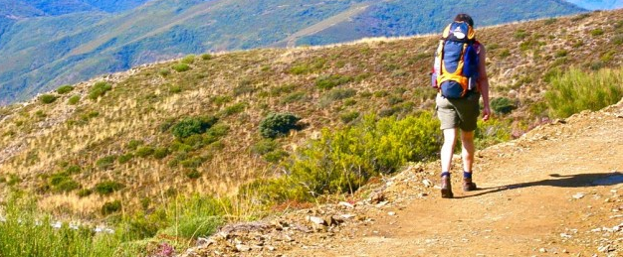

Purpose Projects Volunteer

